LAB NO 02
TASK NO 01:
TAKE STRING:
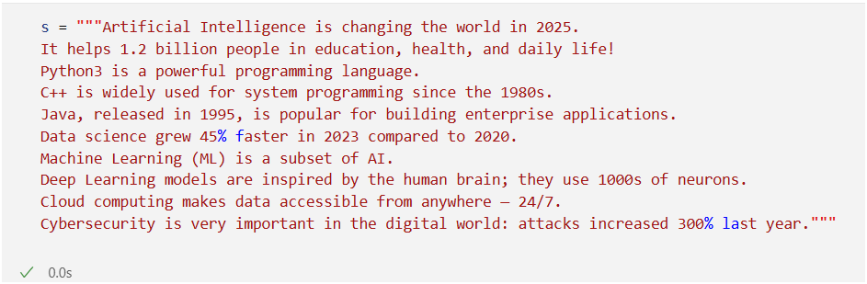
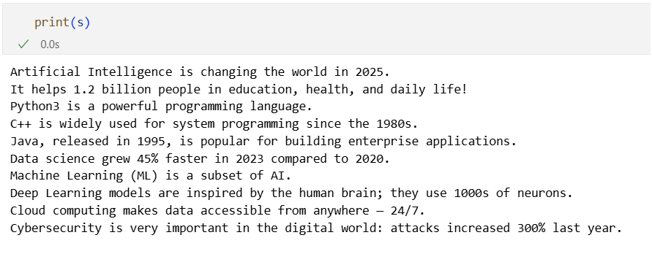
LOWERCASE:
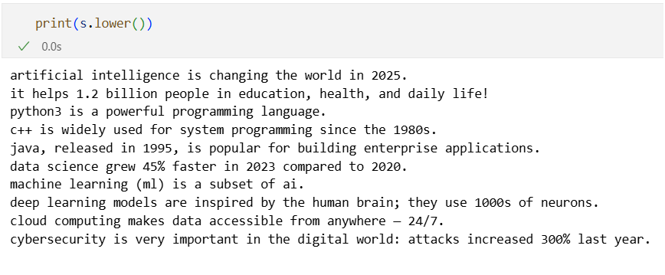
REMOVE NUMBERS:
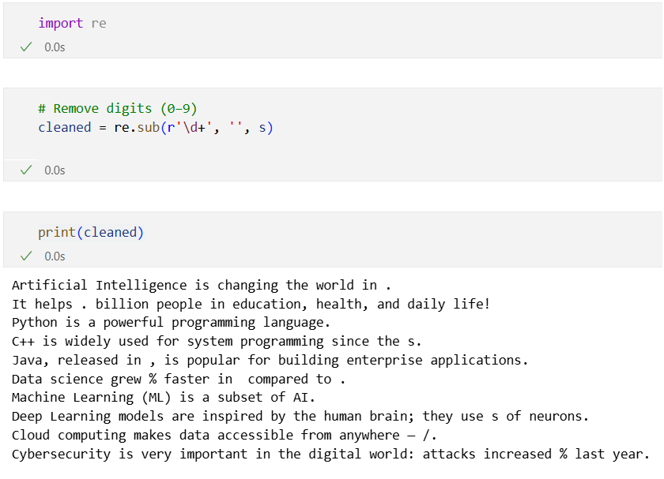
REMOVE PUNCTUATIONS:
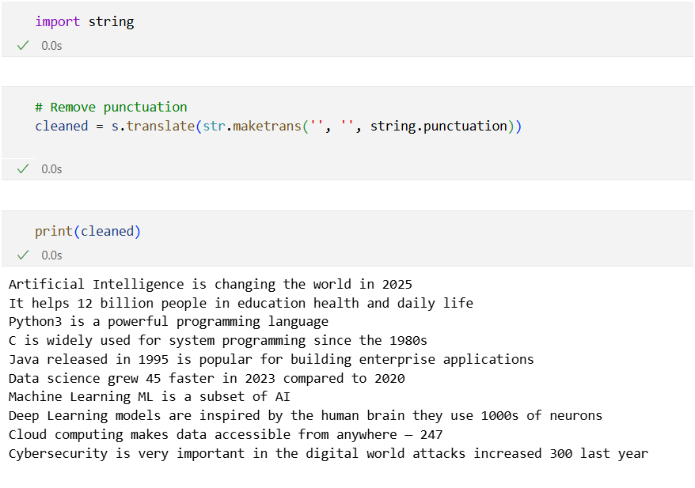
REMOVE STOPWORDS:
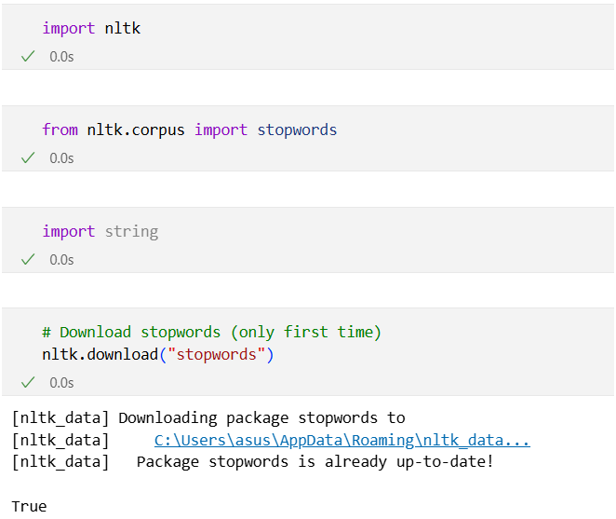
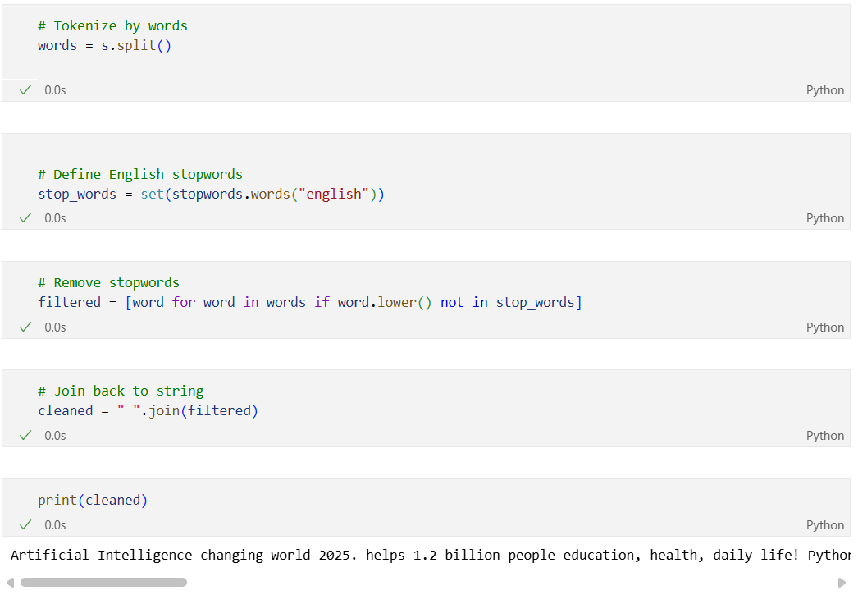
Regular Expressions
TASK NO 02:
- re.findall():
Finds all matches and returns them in a list.
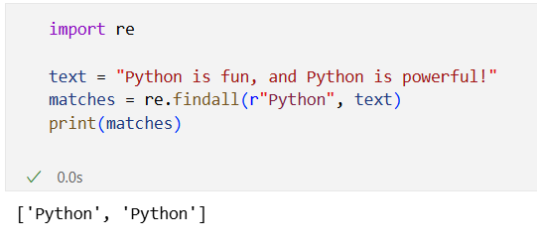

- re.compile()
Compiles a regex pattern into a reusable object.
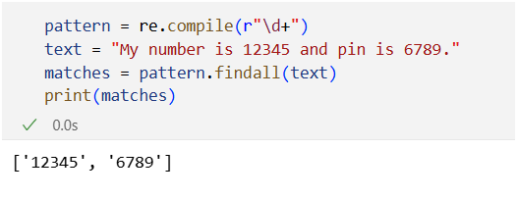

- re.split()
Splits a string by regex pattern.
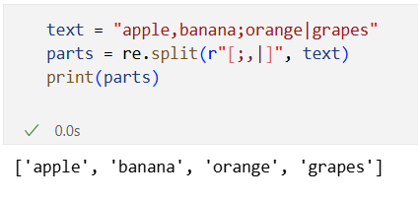
- re.subn()
Replaces matches and returns a tuple (new_string, number_of_subs).
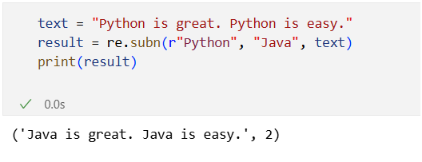
- re.escape()
Escapes special regex characters so they are treated literally.
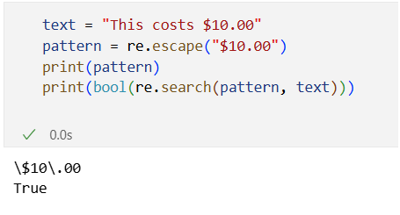
- re.search()
Finds the first match of a pattern.
